**Report of the Project**

**ON**

**CAR RENTAL MANAGEMENT SYSTEM**

Submitted in partial fulfillment of the requirements of the award of the degree of

**B.Sc. (Hons.) Computer Application**

Session 2022-2025



**Under the guidance of : - Submitted By: -**

Vikash Rajak **Student Name: Nikhil Kumar Sahu**

**Roll No: 735**

**Exam Roll No: 22VBCA051668**

**Registration No: 22SXC051668**

**ST. XAVIER’S COLLEGE, RANCHI, JHARKHAND**

**CERTIFICATE**

This to certify that the work presented in the PROJECT REPORT entitled **CAR RENTAL MANAGEMENT SYSTEM** in partial fulfillment of the requirement for award of the degree of Bachelor of Computer Application of **Briztech Info Systems PVT. LTD.,** Lalpur, Ranchi is an authentic work carried out under my supervision and guidance.

To the best of my knowledge, the content of this PROJECT REPORT is original.

__________________

Vikash Rajak

Guide of Briztech

Infosystems PVT. LTD.

Lalpur, Ranchi

**CERTIFICATE OF APPROVAL**

The foregoing PROJECT REPORT entitled CAR RENTAL MANAGEMENT SYSTEM is hereby approved as a creditable work on the topic and has been presented in satisfactory manner to warrant its acceptance as prerequisite to the degree for which it has been submitted.

It is understood that by this approval, the undersigned do not necessarily endorse any conclusion drawn or opinion expressed there in but approve the PROJECT REPORT for the purpose for which it is submitted.

**(Internal Examiner) (External Examiner)**

**B.Sc. (Hons.) Computer Applications**

**ST. XAVIER’S COLLEGE, RANCHI, JHARKHAND**

**ACKNOWLEDGEMENT**

We take this opportunity to thank all who have contributed towards shaping this PROJECT REPORT. I would like to express my sincere thanks to all faculty members, whose invaluable suggestions helped me in development of this PROJECT REPORT. As my supervisor, he has constantly encouraged me to remain focused on achieving my goal.

I would also like to thank all faculty and technical staff members of the Department who have been kind enough to advise and help in their respective roles. I have been fortunate to have wonderful support structure among the graduate students. I am thankful to my friends. My sincere thanks to everyone who has provided me with kind words, new ideas, useful criticism, or their invaluable time, I am truly indebted.

Bearing in mind previous I am using this opportunity to express my deepest gratitude and special thanks to the Instructor of **BRIZTECH INFOSYSTEMS PVT. LTD.** who despite being extraordinarily busy with her/his duties, took time out to hear, guide and keep me on the correct path and allowing me to carry out my project at their esteemed organization and extending during the training.

**Student Name: Nikhil Kumar Sahu**

**Exam Roll No: 22VBCA051668**

**Registration No: 22SXC051668**

**TABLE OF CONTENTS**

|  |  |  |
| --- | --- | --- |
| **S. No.** | **Description** | **Page No.** |
| 1. | Introduction | 6 |
| 2. | Literature Survey | 10 |
| 3. | System Requirements Analysis and Specification | 20 |
| 4. | System Design | 34 |
| 5. | Coding | 35 |
| 6. | Databases | 56 |
| 7. | Snapshots | 62 |
| 8. | Future Scope | 66 |
| 9. | Limitation | 68 |
| 10. | Conclusion | 74 |
| 11. | Bibliography | 75 |

**INTRODUCTION**

**1.1 Introduction**

This project is designed so as to be used by Car Rental Company specializing in renting cars to customers. It is an online system through which customers can view available cars, register, view profile and book car.

**1.2 Reason for the Project**

The advancement in Information Technology and internet penetration has greatly enhanced various business processes and communication between companies (services provider) and their customers of which car rental industry is not left out. This E-Car Rental System is developed to provide the following services:

* Enhance Business Processes: To be able to use internet technology to project the rental company to the global world instead of limiting their services to their local domain alone, thus increase their return on investment (ROI).
* Online Vehicle Reservation: A tools through which customers can reserve available cars online prior to their expected pick-up date or time.
* Customer’s registration: A registration portal to hold customer’s details, monitor their transaction and used same to offer better and improve services to them.
* Group bookings: Allows the customer to book space for a group in the case of weddings or corporate meetings (Event management).

**1.3 Problem Statement**

A car rental is a vehicle that can be used temporarily for a fee during a specified period. Getting a rental car helps people get around despite the fact they do not have access to their own personal vehicle or don't own a vehicle at all. The individual who needs a car must contact a rental car company and contract out for a vehicle. This system increases customer retention and simplify vehicle and staff management.

**1.4 Aims & Objectives**

* To produce a web-based system that allow customer to register and reserve car online and for the company to effectively manage their car rental business.
* To ease customer’s task whenever they need to rent a car.

**1.5 Scope**

This project traverses a lot of areas ranging from business concept to computing field, and required to perform several researches to be able to achieve the project objectives. The area covers include:

* Car rental industry: This includes study on how the car rental business is being done, process involved and opportunity that exist for improvement.
* PHP Technology used for the development of the application.
* General customers as well as the company’s staff will be able to use the system effectively.
* Web-platform means that the system will be available for access 24/7 except when there is a temporary server issue which is expected to be minimal.

**CAR RENTAL SERVICES**

**2.1 How Car Rental Services Work**

A car rental is a vehicle that can be used temporarily for a period of time with a fee. Renting a car assists people to get around even when they do not have access to their own personal vehicle or don't own a vehicle at all. The individual who want to rent a car must first contact the car rental company for the desire vehicle. This can be done online. At this point, this person has to supply some information such as; dates of rental, and type of car. After these details are worked out, the individual renting the car must present a valid Identification Card.

Most companies throughout the industry make a profit based of the type of cars that are rented. The rental cars are categorized into economy, compact, compact premium, premium and luxury. And customers are free to choose any car of their choice based on their purse and availability of such car at the time of reservation.

**2.2 Benefits of Online Car Rental Services**

* This online car rental solution is fully functional and flexible.
* It is very easy to use.
* This online car rental system helps in back office administration by streamlining and standardizing the procedures.
* It saves a lot of time, money and labour.
* Eco-friendly: The monitoring of the vehicle activity and the overall business becomes easy and includes the least of paper work.
* The software acts as an office that is open 24/7.
* It increases the efficiency of the management at offering quality services to the customers.
* It provides custom features development and support with the software.

**FUNCTIONAL AND NON-FUNCTIONAL REQUIREMENTS**

## Functional Requirements

Requirement analysis is a software engineering technique that is composed of the various tasks that determine the needs or conditions that are to be met for a new or altered product, taking into consideration the possible conflicting requirements of the various users.

Functional requirements are those requirements that are used to illustrate the internal working nature of the system, the description of the system, and explanation of each subsystem. It consists of what task the system should perform, the processes involved, which data should the system holds and the interfaces with the user. The functional requirements identified are:

1. Customer’s registration: The system should allow new users to register online and generate membership card.
2. Online reservation of cars: Customers should be able to use the system to make booking and online reservation.
3. Automatic update to database once reservation is made or new customer registered: Whenever there’s new reservation or new registration, the system should be able update the database without any additional efforts from the admin.
4. Feedbacks to customers: It should provide means for customers to leave feedback.

## Non-Functional Requirements

It describes aspects of the system that are concerned with how the system provides the functional requirements. They are:

1. Security**:** The subsystem should provide a high level of security and integrity of the data held by the system, only authorized personnel of the company can gain access to the company’s secured page on the system; and only users with valid password and username can login to view user’s page.
2. Performance and Response time:The system should have high performance rate when executing user’s input and should be able to provide feedback or response within a short time span usually 50 seconds for highly complicated task and 20 to 25 seconds for less complicated task.
3. Error handling:Error should be considerably minimized and an appropriate error message that guides the user to recover from an error should be provided. Validation of user’s input is highly essential. Also the standard time taken to recover from an error should be 15 to 20 seconds.
4. Availability:This system should always be available for access at 24 hours, 7 days a week. Also in the occurrence of any major system malfunctioning, the system should be available in 1 to 2 working days, so that the business process is not severely affected.
5. Ease of use:Considered the level of knowledge possessed by the users of this system, a simple but quality user interface should be developed to make it easy to understand and required less training.

**DATA FLOW DIAGRAMS**

**4.1 Data Flow Diagram (DFD)**

A Data Flow Diagram (DFD) is a graphical representation that depicts the information flow and the transforms that are applied as data moves from input to output.

Figure 4.1 Level 0 DFD of Online Car Rental System

ONLINE CAR

RENTAL . SYSTEM

CUSTOMER

CAR RENTAL COMPANY

RESERVE A CAR

CAR RESERVED

NEW REGISTRATION

LOGIN REQUEST

AUTHENTICATION

REGISTRATION CONFIRMATION

EMAIL FOR RESERVED CAR

ADD CUSTOMER

EMAIL FOR RESERVED CAR

TRANSACTION REPORTS

In this diagram, Customer and Car Rental Company are the two entity sets.

Functions of Customer:

* New Registration
* Login Request
* Registration Confirmation by the System
* Reserve Car
* Car Issued by the System
* Email received for Reserved Car

Functions of Car Rental Company:

* Add Customer
* Send E-Mails for Reserved Car
* View Transaction reports

CUSTOMER

REGISTER AS

NEW MEMBER

RETURN

CAR

SELECT

DETAILS FOR

CAR

RESERVATION

AVAILABLE

CARS

PROCESS

RENTAL

CHOOSE

CAR

MAKE

PAYMENT

LOGIN

FEEDBACK

RESPONSE

TO

FEEDBACK

STAFF

ADMIN

LOGIN

ADD/UPDATE

CAR DETAILS

VIEW

REPORT

CUSTOMER DB

CAR DB

STAFF DB

CUSTOMER

DETAILS

LOGIN

DETAILS

SIGNED IN

FEEDBACK

RESPONSE TO FEEDBACK

LOGIN DETAILS

SIGNED IN

CUSTOMER DB

REPORT

STAFF DB

REPORT

CAR DB REPORT

CAR

RESERVED

Figure 4.2 Level 1 DFD of Online Car Rental System

**USE-CASE DIAGRAMS**

### 5.1 Actor and Use Case Description

Actor and use case description shows the detail description of interaction between the actors and their use cases. The description enables to have a proper understanding of how actor interacts with the system through their use cases.

|  |  |  |
| --- | --- | --- |
| **Actor** | **Use Case** | **Use Case Description** |
| Customer | Register as member | This use case describes the activities of the customer to register online and become a member. Customer's details are required as part of the registration. Login detail is automatically sent to the customer after successful registration. |
| Make reservation | This use case enable customer to search and make reservation. Non-register customer will be directed to register before their reservation can be confirmed. Notification is automatically send to the customer after the task is completed. |
| Return car | This use case describes the event of customer returning the car borrowed, the use case extends "process rental" use case from the staff actor. |
| Give feedback | This use case is used by the customer to provide feedbacks/comment to the company; a confirmation notification will be send to the customer once a feedback has been submitted. |
| Staff | Add new car | This use case is used by the staff to add new car to the company's fleet database. Staff will need to login to activate this use case. |
| Update car details | This use case is used by the staff to edit and modify car details whenever there is new renewal (insurance, road tax). It allows the company to keep up-to-date record of their fleet. |
| Reply to customer’s feedback | This use case describes the event by which staff sends reply to customer's earlier feedback. It depends on `give feedback' use case from the customer. |
| Process rental | This use case described the event by which staff updates the system when customer pick up or when returning car. |
| Admin | Add new staff | This use case describes the event by which Admin add new staff detail to the company's staff database. It is invoke whenever a new staff join the company. |
| View report | This use case is used by the Admin to view transaction report. |

Table 5.1 Actors and Use Case Description

5.2 Use Case Diagram

Admin

Staff

Customer

Reply to customer's feedback

Give feedback/ comments

Update car details

Process rental

Register as member

Add new car

Make reservation

View report

Return car

<<extend>>

Figure 5.1: E-Car Rental System [use case]

**5.3 Use-Case Dependency Diagram**

Reply to customer's

feedback

View transaction

report

View cus tomer's

patronage

Give feedback/

comments

Update car details

Process rental

Register as

Member

Add new car

Make reservation

Early return

View report

Pick car

Return car

Late return

<<include>>

<<include>>

Depends on

<<extend>>

<<extend>>

Depends on

<<extend>>

<<extend>>

Figure 5.2: Use Case Dependency Diagram

**ACTIVITY DIAGRAMS**

## 6.1 Activity Diagram

Activity diagrams graphically represent the sequential business and operational workflows of a system. It is a dynamic diagram that shows the activity and the event that causes the object to be in the particular state. The workflows from activity diagram will serve as guide for system navigation in the final design phase of the system.

**6.1.1 Member Registration**

Customer

E-Car Rental System

Display customer's

welcome screen

Username exist?

Enter username and

password

Send email

confirmation

Accept terms &

conditions

Confirm and

submit

Enter details

Start

End

[Yes]

[No]

Figure 6.1: Register as member

**6.1.2 Profile Modification**

E-Car Rental System

Customer

Send confirmation

notification

Navigate to Edit

Profile

Confirm and submit

Modify your profile

Update database

Log out

Valid?

Login

Start

End

[No]

[Yes]

Figure 6.2: Modify profile

**6.1.3 Reservation of Car**

Customer

E-Car Rental System

merge

Redirect to payment

gateway

Display available

cars

Send confirmation

Choose pickup

location

Choose vehicle class

Choose pick up date

and time

Choose from

available car

Choose return date

and time

Choose return

location

Confirm

Member?

Valid?

Register

Login

Start

End

[No]

[No]

[Yes]

Figure 6.3: Make Reservation

**6.1.4 Customer Feedback**

Customer

E-Car Rental System

Enter your message/remark

Enter your details

Submit feedback

Send notification

Start

End

Figure 6.4: Give feedback/comment

**6.1.5 Payment of Car Rent**

Staff

Check rental detail

Provide member id

Update database

Pay late charges

Overdue?

Confirm return

End

Start

Merge

[No]

[Yes]

Figure 6.5: Rent a Car

**6.1.6 Adding a New Car**

E-Car Rental System

Enter car details

Add to inventory

Valid?

Update status

Login

End

Login

[No]

[Yes]

Staff

Figure 6.6: Add a New Car

**6.1.7 View Report**

Admin

E-Car Rental System

Specify report to view

Confirm and submit

Retrieve report

Valid?

Login

Start

End

[No]

[Yes]

Figure 6.7: View report

**SEQUENCE DIAGRAMS**

## 7.1 Sequence Diagram

ssssIt provides a graphical representation of object interactions over time. Sequence diagrams show an actor, the objects and components they interact with in the execution of a use case. One sequence diagram represents a single Use Case 'scenario' or events. Sequence diagrams show the flow of messagesfrom one object to another, and as such correspond to the methods and events supported by an object.

**7.1.1 Member Registration**



Figure 7.1: Register as member

**7.1.2 Reservation of Car**



Figure 7.2: Make reservation

**7.1.3 Customer Feedback**

Figure 7.3: Give feedback

Customer:ola

Database:"db

001"

System:"sys 01"

Feedback

page:i001

Accept feedback

Send confirmation

Enter details

Enter feedback message

Confirm and submit

Add to database

**7.1.4 Adding a New Car**

# **Figure 7.4:** **Add new car**

staff:John

Control:Admin

Handler

Database:"db

01"

New Car page: P001

Pass to control

Login

Close session

Pass to control

Log out

Add to database

Confirm and submit

Enter new car details

provide admin page

Check validity

**7.1.5 Feedback Response**

Control:Feed

Handler

Database:"db

01"

Staff:John

Interface:i001

End session

Get staff info

Display feedback

Log out

Check validity

Respond to feedback

Select feedback

Login

Figure 7.5: Respond to feedback

**7.1.6 Return Car and Check Rental Details**

Staff:john

Customer:ola

Database:"db

01"

Interface:i001

Confirm if overdue

Update database

Process rental

Check rental details

Provide member id

Figure 7.6: Return car

**7.1.7 View Report**

Report Control:

c008

Admin:Kabir

Database:"db

01"

Report page:

P002

End session

Log out

Check validity

Retrieve report

Specify report

Login

Figure 7.7: View report

**CLASS DIAGRAM**

## 8.1 Class Diagram

The class diagram is the main building block, a number of classes are identified and grouped together in a class diagram which helps to determine the statically relations between those objects.

Figure 8.1 Class Diagram of Online Car Rental System

Customer

- userId : string

- custName : string

- cusAddr : string

- mobile : int

- email : string

register ()

login ()

reservation ()

Reservation

- rid : int

- pickdate : date

- returndate : date

- pickloc : string

- VehicleClass : string

reserve ()

search()

Report

- id : int

- date : date

- title : string

generate ()

print ()

save ()

Staff

- sid : char

- sname : string

- position : string

- mobile : int

addcar ()

modifyInfo ()

Car

- PlateNo : string

- CarName : string

- carType : string

- rent : double

add ()

modify ()

reserve ()

Payment

- id : int

- amount : double

- custName : string

pay ()

confirm ()

Feedback

- id : int

- custName : string

- custEmail : string

send ()

respond ()

Distance chart

- source : string

- destination : 1

get ()

provide ()

Admin

- Id : string

- name : string

add ()

modify ()

view ()

Late return

- lateCharge : double

pay ()

confirm ()

Return

- id : int

- retdate : date

update ()

Early return

confirm ()

Automation

- name : string

get ()

provide ()

alert ()

notify ()

*notify*

*makes*

1..*

1..*

*makes*

1..*

1..*

*makes*

1..*

1..*

*rent*

1

1

*process*

1

1..*

*add*

1

1..*

*View*

1

1..*

*add*

1

1..*

*respond to*

1

1..*

*gives*

1..*

1..*

*alert*

1

1..*

*notify*

1

1..*

*provides*

1

1..*

**SOURCE CODE**

**=================== ./index.php ====================**

**=<!DOCTYPE html>**

**<html lang="en">**

**<head>**

**<title>Car Rental</title>**

**<meta charset="utf-8">**

**<meta name="author" content="pixelhint.com">**

**<meta name="description" content="La casa free real state fully responsive html5/css3 home page website template"/>**

**<meta name="viewport" content="width=device-width, initial-scale=1.0, minimum-scale=1.0" />**

**<link rel="stylesheet" type="text/css" href="css/reset.css">**

**<link rel="stylesheet" type="text/css" href="css/responsive.css">**

**<script type="text/javascript" src="js/jquery.js"></script>**

**<script type="text/javascript" src="js/main.js"></script>**

**</head>**

**<body>**

**<section class="">**

**<?php**

**include 'header.php';**

**?>**

**<section class="caption">**

**<h2 class="caption" style="text-align: center"><i>Find Your Dream Cars For Rent!</i></h2>**

**<h3 class="properties" style="text-align: center">Mercedes Benz - Toyota - Range Rovers</h3>**

**</section>**

**</section><!--  end hero section  -->**

**<section class="listings">**

**<div class="wrapper">**

**<ul class="properties_list">**

**<?php**

**include 'includes/config.php';**

**$sel = "SELECT * FROM cars WHERE status = 'Available'";**

**$rs = $conn->query($sel);**

**while($rws = $rs->fetch_assoc()){**

**?>**

**<li>**

**<a href="book_car.php?id=<?php echo $rws['car_id'] ?>">**

**<img class="thumb" src="cars/<?php echo $rws['image'];?>" width="300" height="200">**

**</a>**

**<span class="price"><?php echo 'Rs.'.$rws['hire_cost'];?></span>**

**<div class="property_details">**

**<h1>**

**<a href="book_car.php?id=<?php echo $rws['car_id'] ?>"><?php echo 'Car Make>'.$rws['car_type'];?></a>**

**</h1>**

**<h2>Car Name/Model: <span class="property_size"><?php echo $rws['car_name'];?></span></h2>**

**</div>**

**</li>**

**<?php**

**}**

**?>**

**</ul>**

**</div>**

**</section>  <!--  end listing section  -->**

**<footer>**

**<div class="wrapper footer">**

**<ul>**

**<li class="links">**

**<ul>**

**<li>OUR COMPANY</li>**

**<li><a href="#">About Us</a></li>**

**<li><a href="#">Terms</a></li>**

**<li><a href="#">Policy</a></li>**

**<li><a href="#">Contact</a></li>**

**</ul>**

**</li>**

**<li class="links">**

**<ul>**

**<li>OTHERS</li>**

**<li><a href="#">...</a></li>**

**<li><a href="#">...</a></li>**

**<li><a href="#">...</a></li>**

**<li><a href="#">...</a></li>**

**</ul>**

**</li>**

**<li class="links">**

**<ul>**

**<li>OUR CAR TYPES</li>**

**<li><a href="#">Mercedes</a></li>**

**<li><a href="#">Range Rover</a></li>**

**<li><a href="#">Landcruisers</a></li>**

**<li><a href="#">Others.</a></li>**

**</ul>**

**</li>**

**<li class="about">**

**<p>Our company rents cars and other vehicles to clients at lower costs.</p>**

**<ul>**

**<li><a href="http://facebook.com/codeprojectsdotorg/" class="facebook" target="_blank"></a></li>**

**<li><a href="http://twitter.com/" class="twitter" target="_blank"></a></li>**

**<li><a href="http://plus.google.com/" class="google" target="_blank"></a></li>**

**<li><a href="#" class="skype"></a></li>**

**</ul>**

**</li>**

**</ul>**

**</div>**

**<div class="copyrights wrapper">**

**Copyright &copy; <?php echo date("Y")?> Simple Car Rental System - Brought To You By <a href= "http://code-projects.org/"> Code-Projects </a>**

**</div>**

**</footer><!--  end footer  -->**

**</body>**

**</html>**

**==================== ./account.php ====================**

**<?php include 'header.php'; ?>**

**<section class="caption">**

**<h2>Find You Dream Cars For Hire</h2>**

**<h3>Range Rovers - Mercedes Benz - Landcruisers</h3>**

**</section>**

**<section class="search">**

**<div class="wrapper">**

**<form method="post">**

**<h3>Client Login Area</h3>**

**<table>**

**<tr><td>Email:</td><td><input type="email" name="email" required></td></tr>**

**<tr><td>Password:</td><td><input type="password" name="pass" required></td></tr>**

**<tr><td><input type="submit" name="log" value="Login"></td><td><a href="signup.php">Signup</a></td></tr>**

**</table>**

**</form>**

**<?php**

**if(isset($_POST['log'])){**

**include 'includes/config.php';**

**$uname = $_POST['email'];**

**$pass = $_POST['pass'];**

**$qy = "SELECT * FROM client WHERE email = '$uname' AND id_no = '$pass'";**

**$log = $conn->query($qy);**

**$num = $log->num_rows;**

**$row = $log->fetch_assoc();**

**if($num > 0){**

**session_start();**

**$_SESSION['email'] = $row['email'];**

**$_SESSION['pass'] = $row['id_no'];**

**echo "<script>alert('Login Successful.'); window.location = 'index.php';</script>";**

**} else{**

**echo "<script>alert('Login Failed.'); window.location = 'account.php';</script>";**

**}**

**}**

**?>**

**</div>**

**</section>**

**==================== ./admin/add_cars.php ====================**

**<?php include '../includes/config.php'; include 'menu.php'; ?>**

**<div class="box">**

**<h2>Add New Vehicles</h2>**

**<form method="post" enctype="multipart/form-data">**

**<p><label>Vehicle Name</label><input type="text" name="car_name" required /></p>**

**<p><label>Vehicle Make</label><input type="text" name="car_type" required /></p>**

**<p><label>Hire Price</label><input type="text" name="hire_cost" required /></p>**

**<p><label>Vehicle Image</label><input type="file" name="image" required /></p>**

**<p><label>Vehicle Capacity</label><input type="text" name="capacity" required /></p>**

**<input type="submit" value="submit" name="send" />**

**</form>**

**<?php**

**if(isset($_POST['send'])){**

**$target_path = "../cars/" . basename($_FILES['image']['name']);**

**if(move_uploaded_file($_FILES['image']['tmp_name'], $target_path)){**

**$image = basename($_FILES['image']['name']);**

**$car_name = $_POST['car_name'];**

**$car_type = $_POST['car_type'];**

**$hire_cost = $_POST['hire_cost'];**

**$capacity = $_POST['capacity'];**

**$qr = "INSERT INTO cars (image, car_name,car_type,hire_cost,capacity,status) VALUES ('$image','$car_name','$car_type','$hire_cost','$capacity','Available')";**

**$res = $conn->query($qr);**

**if($res === TRUE){**

**echo "<script>alert('Vehicle Successfully Added'); window.location = 'add_vehicles.php';</script>";**

**}**

**}**

**}**

**?>**

**</div>**

**==================== ./admin/add_vehicles.php ====================**

**<?php include 'menu.php'; ?>**

**<div class="box">**

**<h2>Our Vehicles</h2>**

**<table>**

**<tr><th>Vehicle Make</th><th>Car Type</th><th>Hire Price</th><th>Control</th></tr>**

**<?php**

**include '../includes/config.php';**

**$select = "SELECT * FROM cars WHERE status = 'Available'";**

**$result = $conn->query($select);**

**while($row = $result->fetch_assoc()){**

**?>**

**<tr>**

**<td><?php echo $row['car_type'] ?></td>**

**<td><?php echo $row['car_name'] ?></td>**

**<td><?php echo $row['hire_cost'] ?></td>**

**<td><a href="javascript:sureToApprove(<?php echo $row['car_id'];?>)">Delete</a></td>**

**</tr>**

**<?php } ?>**

**</table>**

**</div>**

**==================== ./admin/approve.php ====================**

**<?php**

**include '../includes/config.php';**

**$id = $_REQUEST['id'];**

**$query = "UPDATE client SET status = 'Approved' WHERE client_id = '$id'";**

**$result = $conn->query($query);**

**if($result === TRUE){**

**echo 'Request has Successfully been Approved';**

**echo '<meta content="4; client_requests.php" http-equiv="refresh" />';**

**}**

**?>**

**==================== ./admin/client_requests.php ====================**

**<?php include 'menu.php'; ?>**

**<div class="box">**

**<h2>Client Requests</h2>**

**<table>**

**<tr><th>Client Name</th><th>Phone</th><th>Car Booked</th><th>Mpesa ID</th><th>Status</th><th>Control</th></tr>**

**<?php**

**include '../includes/config.php';**

**$select = "SELECT client.client_id,client.fname,client.phone,cars.car_name,cars.hire_cost,client.status FROM client JOIN cars ON client.car_id=cars.car_id";**

**$result = $conn->query($select);**

**while($row = $result->fetch_assoc()){**

**?>**

**<tr>**

**<td><?php echo $row['fname'] ?></td>**

**<td><?php echo $row['phone'] ?></td>**

**<td><?php echo $row['car_name'] ?></td>**

**<td><?php echo $row['hire_cost'] ?></td>**

**<td><?php echo $row['status'] ?></td>**

**<td><a href="javascript:sureToApprove(<?php echo $row['client_id'];?>)">Approve</a></td>**

**</tr>**

**<?php } ?>**

**</table>**

**</div>**

**==================== ./admin/delete.php ====================**

**<?php**

**include '../includes/config.php';**

**$id = $_REQUEST['id'];**

**$query = "DELETE FROM client WHERE client_id = '$id'";**

**$result = $conn->query($query);**

**if($result === TRUE){**

**echo 'Request has Successfully been Deleted';**

**echo '<meta content="4; client_requests.php" http-equiv="refresh" />';**

**}**

**?>**

**==================== ./admin/delete_car.php ====================**

**<?php**

**include '../includes/config.php';**

**$id = $_REQUEST['id'];**

**$query = "DELETE FROM cars WHERE car_id = '$id'";**

**$result = $conn->query($query);**

**if($result === TRUE){**

**echo "<script>alert('Car Successfully Deleted'); window.location = 'add_vehicles.php';</script>";**

**}**

**?>**

**==================== ./admin/delete_msg.php ====================**

**<?php**

**include '../includes/config.php';**

**$id = $_REQUEST['id'];**

**$query = "DELETE FROM message WHERE msg_id = '$id'";**

**$result = $conn->query($query);**

**if($result === TRUE){**

**echo "<script>alert('Message Successfully Deleted'); window.location = 'index.php';</script>";**

**}**

**?>**

**==================== ./admin/index.php ====================**

**<?php include 'menu.php'; ?>**

**<div class="box">**

**<h2>Client Messages</h2>**

**<table>**

**<tr><th>Message Content</th><th>Time Send</th><th>Status</th><th>Control</th></tr>**

**<?php**

**include '../includes/config.php';**

**$select = "SELECT * FROM message";**

**$result = $conn->query($select);**

**while($row = $result->fetch_assoc()){**

**?>**

**<tr>**

**<td><?php echo $row['message'] ?></td>**

**<td><?php echo $row['time'] ?></td>**

**<td><?php echo $row['status'] ?></td>**

**<td><a href="javascript:sureToApprove(<?php echo $row['msg_id'];?>)">Delete</a></td>**

**</tr>**

**<?php } ?>**

**</table>**

**</div>**

**==================== ./admin/logout.php ====================**

**<?php**

**session_start();**

**session_destroy();**

**echo "<script>alert('User Logged Out'); window.location = '../index.php';</script>";**

**?>**

**==================== ./admin/menu.php ====================**

**<?php**

**error_reporting("E-NOTICE");**

**session_start();**

**if(!$_SESSION['uname'] && (!$_SESSION['pass'])){**

**header("location: ../login.php");**

**}**

**?>**

**<div id="top">**

**<h1>Car Rental System</h1>**

**<div id="top-navigation">**

**Welcome <strong>Administrator</strong> | <a href="logout.php">Log out</a>**

**</div>**

**</div>**

**<div id="navigation">**

**<ul>**

**<li><a href="index.php">Dashboard</a></li>**

**<li><a href="add_vehicles.php">Vehicle Management</a></li>**

**<li><a href="client_requests.php">Hire Requests</a></li>**

**<li><a href="index.php">Messages</a></li>**

**</ul>**

**</div>**

**==================== ./book_car.php ====================**

**<?php include 'header.php'; ?>**

**<section class="listings">**

**<div class="wrapper">**

**<?php**

**include 'includes/config.php';**

**$sel = "SELECT * FROM cars WHERE car_id = '$_GET[id]'";**

**$rs = $conn->query($sel);**

**$rws = $rs->fetch_assoc();**

**?>**

**<img src="cars/<?php echo $rws['image'];?>" width="300" height="200">**

**<span><?php echo 'Rs.'.$rws['hire_cost'];?></span>**

**<h1><?php echo 'Car Make>'.$rws['car_type'];?></h1>**

**<h2>Car Name: <?php echo $rws['car_name'];?></h2>**

**<h3>Proceed to Hire <?php echo $rws['car_name'];?></h3>**

**<?php if(!$_SESSION['email'] && (!$_SESSION['pass'])){ ?>**

**<form method="post">**

**<table>**

**<tr><td>Full Name:</td><td><input type="text" name="fname" required></td></tr>**

**<tr><td>Phone:</td><td><input type="text" name="phone" required></td></tr>**

**<tr><td>Email:</td><td><input type="email" name="email" required></td></tr>**

**<tr><td>ID Number:</td><td><input type="text" name="id_no" required></td></tr>**

**<tr><td>Gender:</td><td><select name="gender"><option>Male</option><option>Female</option></select></td></tr>**

**<tr><td>Location:</td><td><input type="text" name="location" required></td></tr>**

**<tr><td colspan="2"><input type="submit" name="save" value="Submit Details"></td></tr>**

**</table>**

**</form>**

**<?php } else { ?>**

**<a href="pay.php">Click to Book</a>**

**<?php } ?>**

**<?php**

**if(isset($_POST['save'])){**

**include 'includes/config.php';**

**$fname = $_POST['fname'];**

**$id_no = $_POST['id_no'];**

**$gender = $_POST['gender'];**

**$email = $_POST['email'];**

**$phone = $_POST['phone'];**

**$location = $_POST['location'];**

**$qry = "INSERT INTO client (fname,id_no,gender,email,phone,location,car_id,status) VALUES('$fname','$id_no','$gender','$email','$phone','$location','$_GET[id]','Pending')";**

**$result = $conn->query($qry);**

**if($result == TRUE){**

**echo "<script>alert('Successfully Registered. Proceed to pay'); window.location = 'pay.php';</script>";**

**} else{**

**echo "<script>alert('Registration Failed.'); window.location = 'book_car.php';</script>";**

**}**

**}**

**?>**

**</div>**

**</section>**

**==================== ./contact.php ====================**

**<?php include 'header.php'; ?>**

**<h3>Contact Us</h3>**

**<div class="container">**

**<form>**

**<label>First Name</label><input type="text" name="firstname" placeholder="Your name..">**

**<label>Last Name</label><input type="text" name="lastname" placeholder="Your last name..">**

**<label>Country</label>**

**<select name="country">**

**<option value="australia">Australia</option>**

**<option value="canada">Canada</option>**

**<option value="usa">USA</option>**

**</select>**

**<label>Subject</label><textarea name="subject" placeholder="Write something.."></textarea>**

**<input type="submit" value="Submit">**

**</form>**

**</div>**

**==================== ./header.php ====================**

**<?php**

**session_start();**

**error_reporting("E-NOTICE");**

**?>**

**<header>**

**<div class="wrapper">**

**<h1 class="logo">Simple Car Rental System</h1>**

**<nav>**

**<?php if(!$_SESSION['email'] && (!$_SESSION['pass'])){ ?>**

**<ul>**

**<li><a href="index.php">Home</a></li>**

**<li><a href="index.php">Rent Cars</a></li>**

**<li><a href="contact.php">Contact</a></li>**

**<li><a href="account.php">Client Login</a></li>**

**<li><a href="login.php">Admin Login</a></li>**

**</ul>**

**<?php } else{ ?>**

**<ul>**

**<li><a href="index.php">Home</a></li>**

**<li><a href="status.php">View Status</a></li>**

**<li><a href="message_admin.php">Message Admin</a></li>**

**<li><a href="admin/logout.php">Logout</a></li>**

**</ul>**

**<?php } ?>**

**</nav>**

**</div>**

**</header>**

**==================== ./includes/config.php ====================**

**<?php**

**$host = "localhost";**

**$user = "root";**

**$pass = "";**

**$db = "cars";**

**$conn = new mysqli($host, $user, $pass, $db);**

**if($conn->connect_error){**

**echo "Failed:" . $conn->connect_error;**

**}**

**?>**

**==================== ./index.php ====================**

**<?php include 'header.php'; ?>**

**<section class="caption">**

**<h2>Find Your Dream Cars For Rent!</h2>**

**<h3>Mercedes Benz - Toyota - Range Rovers</h3>**

**</section>**

**<section class="listings">**

**<div class="wrapper">**

**<ul class="properties_list">**

**<?php**

**include 'includes/config.php';**

**$sel = "SELECT * FROM cars WHERE status = 'Available'";**

**$rs = $conn->query($sel);**

**while($rws = $rs->fetch_assoc()){**

**?>**

**<li>**

**<a href="book_car.php?id=<?php echo $rws['car_id'] ?>">**

**<img src="cars/<?php echo $rws['image'];?>" width="300" height="200">**

**</a>**

**<span><?php echo 'Rs.'.$rws['hire_cost'];?></span>**

**<div>**

**<h1><a href="book_car.php?id=<?php echo $rws['car_id'] ?>"><?php echo 'Car Make>'.$rws['car_type'];?></a></h1>**

**<h2>Car Name: <?php echo $rws['car_name'];?></h2>**

**</div>**

**</li>**

**<?php } ?>**

**</ul>**

**</div>**

**</section>**

**==================== ./login.php ====================**

**<?php include 'header.php'; ?>**

**<section class="search">**

**<div class="wrapper">**

**<form method="post">**

**<h3>Admin Login Area</h3>**

**<table>**

**<tr><td>Username:</td><td><input type="text" name="uname" required></td></tr>**

**<tr><td>Password:</td><td><input type="password" name="pass" required></td></tr>**

**<tr><td colspan="2"><input type="submit" name="login" value="Login"></td></tr>**

**</table>**

**</form>**

**<?php**

**if(isset($_POST['login'])){**

**include 'includes/config.php';**

**$uname = $_POST['uname'];**

**$pass = $_POST['pass'];**

**$query = "SELECT * FROM admin WHERE uname = '$uname' AND pass = '$pass'";**

**$rs = $conn->query($query);**

**$num = $rs->num_rows;**

**$rows = $rs->fetch_assoc();**

**if($num > 0){**

**session_start();**

**$_SESSION['uname'] = $rows['uname'];**

**$_SESSION['pass'] = $rows['pass'];**

**echo "<script>alert('Login Successful'); window.location = 'admin/index.php';</script>";**

**} else{**

**echo "<script>alert('Login Failed'); window.location = 'login.php';</script>";**

**}**

**}**

**?>**

**</div>**

**</section>**

**==================== ./message_admin.php ====================**

**<?php include 'header.php'; ?>**

**<section class="listings">**

**<div class="wrapper">**

**<h2>Message Admin Here</h2>**

**<form method="post">**

**<table>**

**<tr><td>Enter Your Message:</td></tr>**

**<tr><td><textarea name="message" placeholder="Enter Message Here"></textarea></td></tr>**

**<tr><td><input type="submit" name="send" value="Send Message"></td></tr>**

**</table>**

**</form>**

**<?php**

**if(isset($_POST['send'])){**

**include 'includes/config.php';**

**$message = $_POST['message'];**

**$qry = "INSERT INTO message (message,client_id,time,status) VALUES('$message','$_SESSION[email]',NOW(),'Unread')";**

**$result = $conn->query($qry);**

**if($result == TRUE){**

**echo "<script>alert('Message Successfully Send'); window.location = 'success.php';</script>";**

**} else{**

**echo "<script>alert('Message Not Send'); window.location = 'message_admin.php';</script>";**

**}**

**}**

**?>**

**</div>**

**</section>**

**==================== ./pay.php ====================**

**<?php include 'header.php'; ?>**

**<section class="listings">**

**<div class="wrapper">**

**<h3>Make Payments Here</h3>**

**<h5>Paybill Number: 00000</h5>**

**<h6>Business Number: ID Number Registered with.</h6>**

**<form method="post">**

**<table>**

**<tr><td>MPESA Transaction ID:</td><td><input type="text" name="mpesa" required></td></tr>**

**<tr><td>National ID Number:</td><td><input type="text" name="id_no" required></td></tr>**

**<tr><td colspan="2"><input type="submit" name="pay" value="Submit Details"></td></tr>**

**</table>**

**</form>**

**<?php**

**if(isset($_POST['pay'])){**

**include 'includes/config.php';**

**$mpesa = $_POST['mpesa'];**

**$id_no = $_POST['id_no'];**

**$qry = "UPDATE client SET mpesa = '$mpesa' WHERE id_no = '$id_no'";**

**$result = $conn->query($qry);**

**if($result == TRUE){**

**echo "<script>alert('Payment Successfully Done'); window.location = 'wait.php';</script>";**

**} else{**

**echo "<script>alert('Registration Failed'); window.location = 'pay.php';</script>";**

**}**

**}**

**?>**

**</div>**

**</section>**

**==================== ./signup.php ====================**

**<?php include 'header.php'; ?>**

**<section class="listings">**

**<div class="wrapper">**

**<h3>Signup Here</h3>**

**<form method="post">**

**<table>**

**<tr><td>Full Name:</td><td><input type="text" name="fname" required></td></tr>**

**<tr><td>Phone:</td><td><input type="text" name="phone" required></td></tr>**

**<tr><td>Email:</td><td><input type="email" name="email" required></td></tr>**

**<tr><td>ID Number:</td><td><input type="text" name="id_no" required></td></tr>**

**<tr><td>Gender:</td><td><select name="gender"><option>Male</option><option>Female</option></select></td></tr>**

**<tr><td>Location:</td><td><input type="text" name="location" required></td></tr>**

**<tr><td colspan="2"><input type="submit" name="save" value="Submit Details"></td></tr>**

**</table>**

**</form>**

**<?php**

**if(isset($_POST['save'])){**

**include 'includes/config.php';**

**$fname = $_POST['fname'];**

**$id_no = $_POST['id_no'];**

**$gender = $_POST['gender'];**

**$email = $_POST['email'];**

**$phone = $_POST['phone'];**

**$location = $_POST['location'];**

**$qry = "INSERT INTO client (fname,id_no,gender,email,phone,location,status) VALUES('$fname','$id_no','$gender','$email','$phone','$location','Available')";**

**$result = $conn->query($qry);**

**if($result == TRUE){**

**echo "<script>alert('Successfully Registered'); window.location = 'account.php';</script>";**

**} else{**

**echo "<script>alert('Registration Failed'); window.location = 'signup.php';</script>";**

**}**

**}**

**?>**

**</div>**

**</section>**

**==================== ./status.php ====================**

**<?php include 'header.php'; ?>**

**<section class="listings">**

**<div class="wrapper">**

**<h2>Your Booking Status</h2>**

**<?php**

**include 'includes/config.php';**

**$sel = "SELECT * FROM client WHERE email = '$_SESSION[email]'";**

**$rs = $conn->query($sel);**

**$rws = $rs->fetch_assoc();**

**?>**

**<h2>Booking Status: <?php echo $rws['status'];?></h2>**

**</div>**

**</section>**

**==================== ./success.php ====================**

**<?php include 'header.php'; ?>**

**<section class="listings">**

**<div class="wrapper">**

**<h2>Thank you for contacting us. We will give you a call shortly.</h2>**

**</div>**

**</section>**

**==================== ./wait.php ====================**

**<?php include 'header.php'; ?>**

**<section class="listings">**

**<div class="wrapper">**

**<h2>Thank you for sending a request to our Team. We will get back to you once we verify your payment.<br>**

**You can login to view the processing status using your email and National ID Number as password.</h2>**

**</div>**

**</section>**

**SNAPSHOTS**

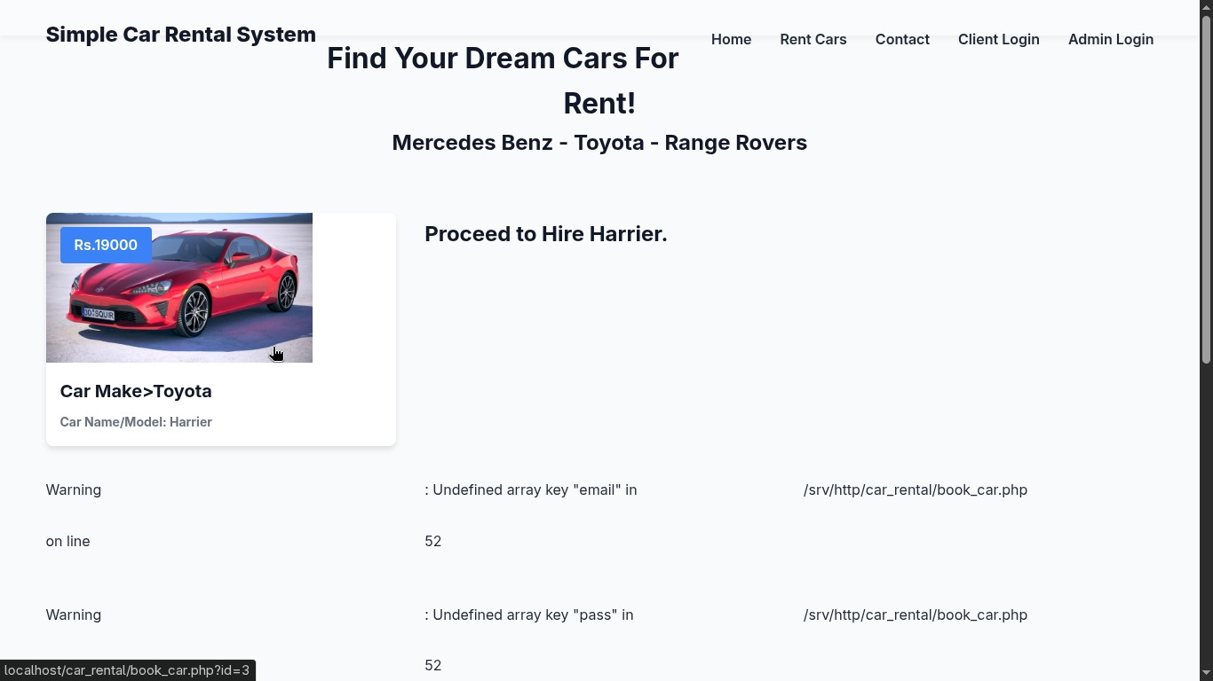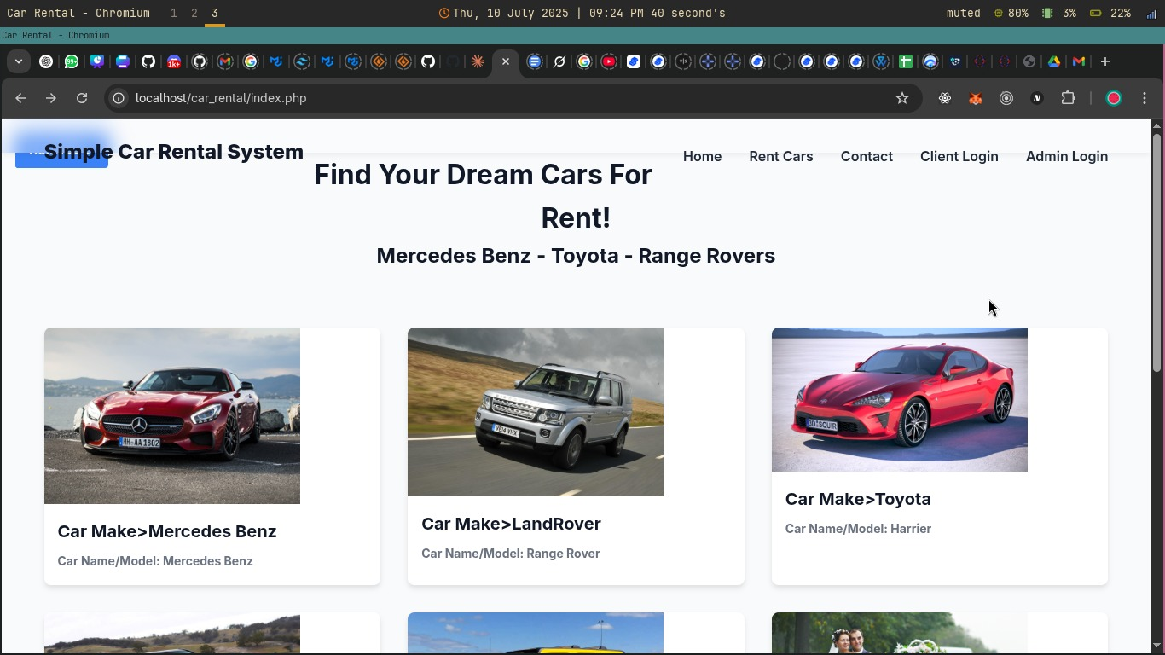

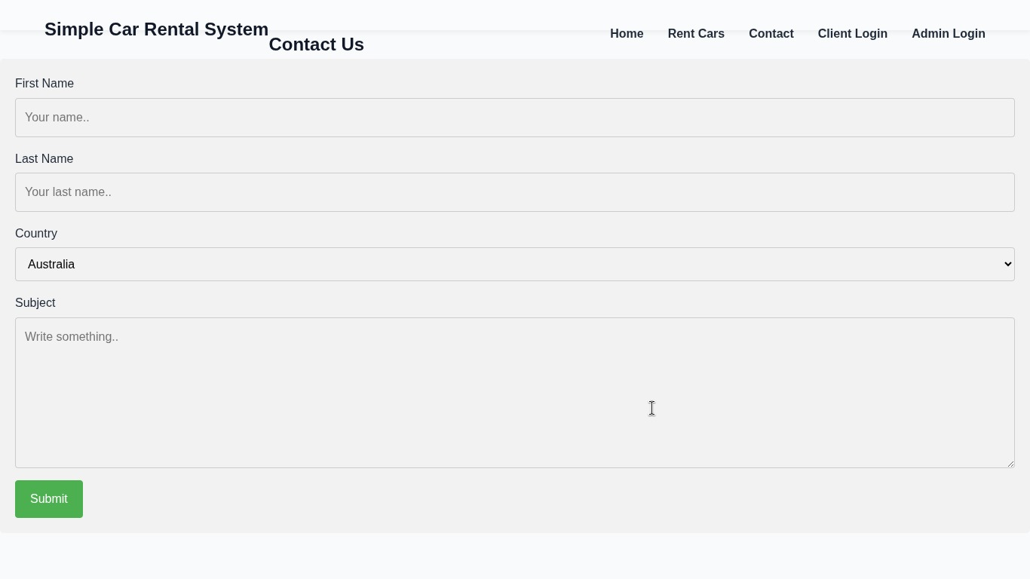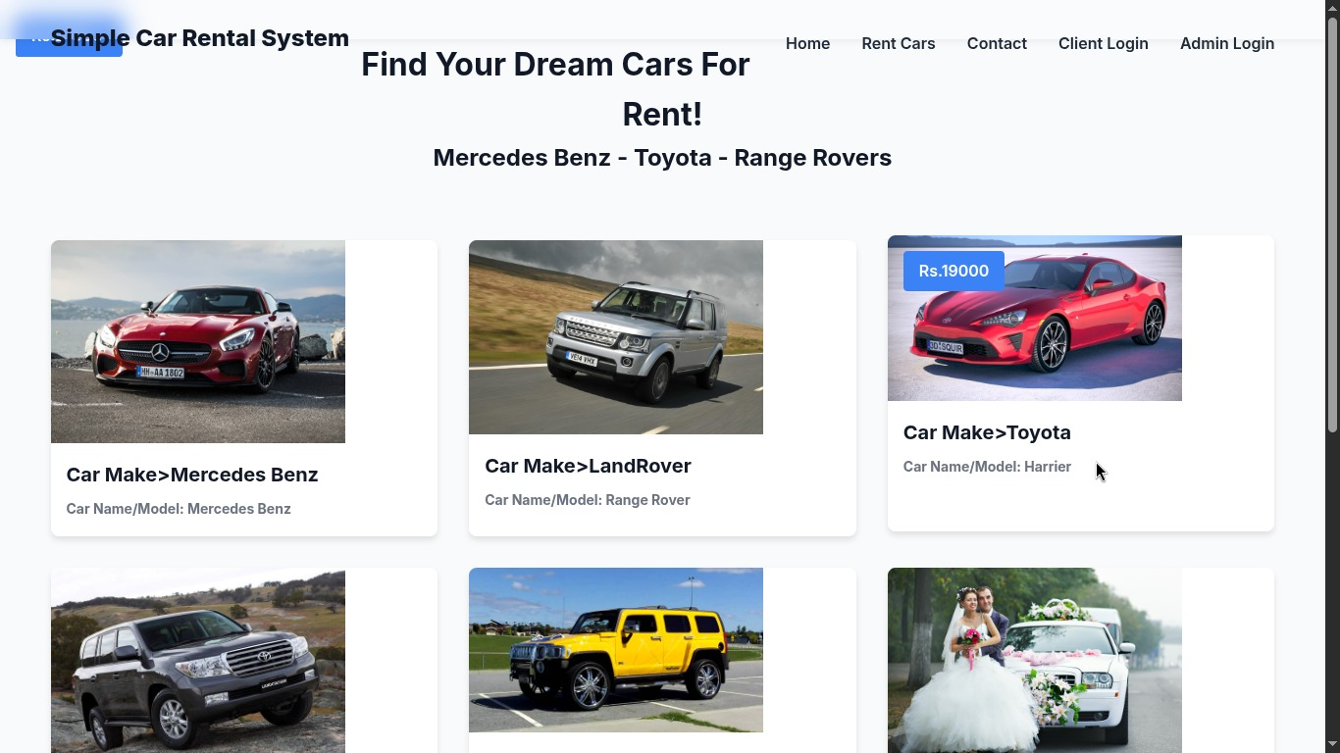

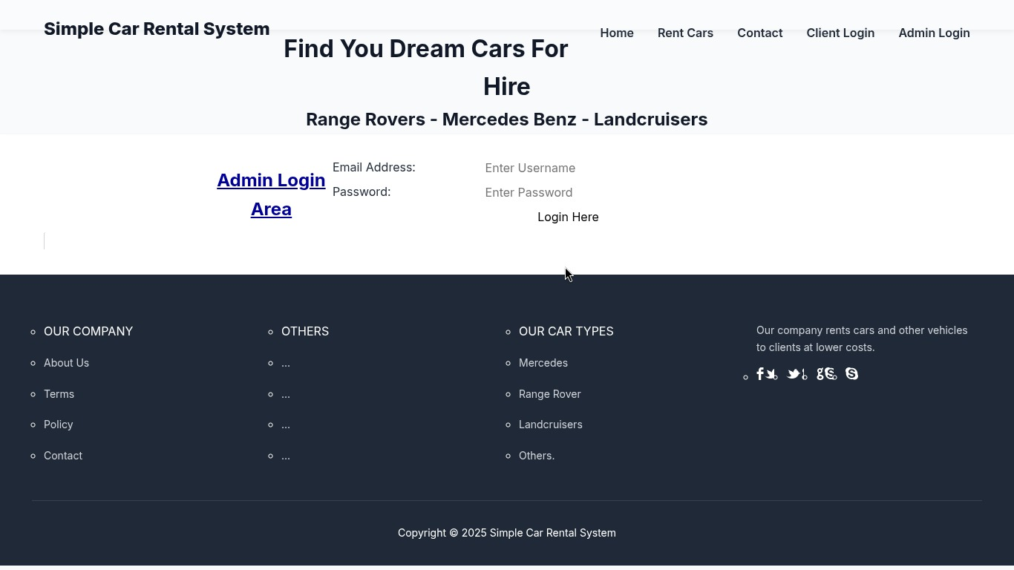

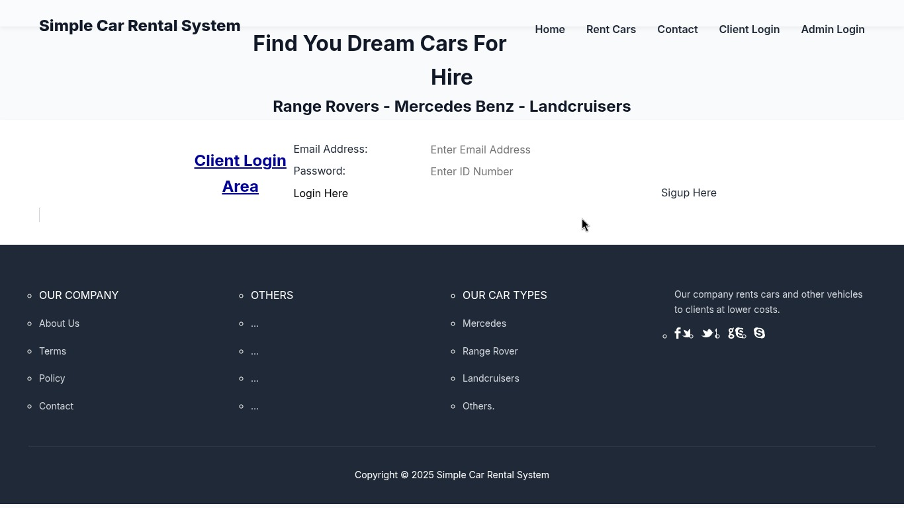





**INTRODUCTION OF TECHNOLOGIES USED IN PROJECT**

**9.1 About PHP**

**PHP: Hypertext Pre-processor** is a widely used, general-purpose scripting language that was originally designed for web development to produce dynamic web pages. For this purpose, PHP code is embedded into the HTML source document and interpreted by a web server with a PHP processor module, which generates the web page document.

As a general-purpose programming language, PHP code is processed by an interpreter application in command-line mode performing desired operating system operations and producing program output on its standard output channel. It may also function as a graphical application. PHP is available as a processor for most modern web servers and as standalone interpreter on most operating systems and computing platforms.

PHP was originally created by Rasmus Lerdorf in 1995 and has been in continuous development ever since. The main implementation of PHP is now produced by the PHP Group and serves as the *de facto* standard for PHP as there is no formal specification. PHP is free software released under the PHP License.

PHP is a general-purpose scripting language that is especially suited to server-side web development where PHP generally runs on a web server. Any PHP code in a requested file is executed by the PHP runtime, usually to create dynamic web page content. It can also be used for command-line scripting and client-side GUI applications. PHP can be deployed on most web servers, many operating systems and platforms, and can be used with many relational database management systems. It is available free of charge, and the PHP Group provides the complete source code for users to build, customize and extend for their own use.

Originally designed to create dynamic web pages, PHP now focuses mainly on server-side scripting, and it is similar to other server-side scripting languages that provide dynamic content from a web server to a client, such as Microsoft's Active Server Pages, Sun Microsystems’ Java Server Pages, and mod_perl. PHP has also attracted the development of many frameworks that provide building blocks and a design structure to promote rapid application development (RAD). Some of these include CakePHP, Symfony, CodeIgniter and Zend Framework, offering features similar to other web application frameworks.

**9.2 PHP Syntax:**

HTML and PHP code is written on the same page, and to distinguish PHP code from HTML, the PHP code is enclosed within <? php ?> Tags.

For example:

<html>

<head><title>php basics</title></head>

<body>

<h2>HELLO</h1>

<?php

echo "hello";

?>

</body>

</html>

In the above example PHP code is embedded within HTML. In this way PHP and HTML coding is combined on the same page.

Since PHP is a server side scripting language, the PHP coding cannot be seen by the end user through view source option, due to this feature PHP is very secure.

PHP is a parsed language; therefore PHP environment is necessary at the server for running PHP scripts.

**9.3 Working of PHP:**

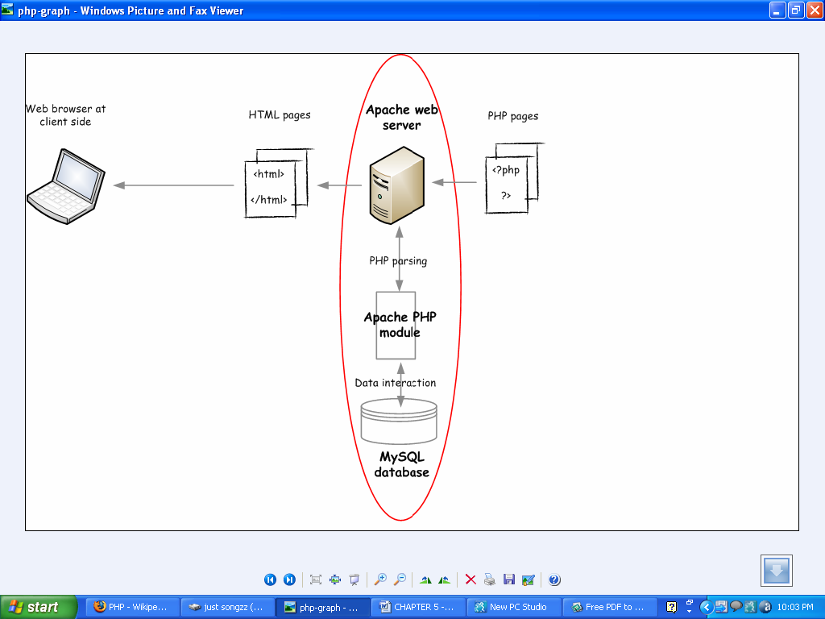

Figure 9.1 Working of PHP

When a client requests web page containing PHP code from the server, then the requested PHP pages are parsed under PHP environment and interaction with database is made if required.

After server side processing, the resulting HTML pages are passed to client and displayed on the browser.

In this way the working of php is complete.

**9.4 Connecting PHP Application to MySQL Database**

1) Make a connection variable to the database:

$con= mysql_connect ("localhost","servername","password");

Here $con is a connection variable to database.

2) Select a database over that connection variable:

$db=mysql_select_db("databasename",$con);

3) Prepare a sql query to execute:

$qry= Select * from abc;

4) Run the sql query:

$result=mysql_query($qry);

5) Iterate over the result:

while($row = mysql_fetch_array($result))

{

//some logic

}

**9.5 Introduction to MySQL:**

**MySQL** is a relational database management system (RDBMS) that runs as a server providing multi-user access to a number of databases. MySQL is officially pronounced ("My S-Q-L"), but is often pronounced ("My Sequel"). It is named for original developer Michael Widenius's daughter My.

The MySQL development project has made its source code available under the terms of the GNU General Public License, as well as under a variety of proprietary agreements. MySQL is owned and sponsored by a single for-profit firm, the Swedish company MySQL AB, now owned by Sun Microsystems, a subsidiary of Oracle Corporation.

MySQL code uses C and C++. The SQL parser uses yacc and a home-brewed lexer, sql_lex.cc.

MySQL works on many different system platforms, including AIX, BSDi, FreeBSD, HP-UX, i5/OS, Linux, Mac OS X, NetBSD, Novell NetWare, OpenBSD, OpenSolaris, eComStation, OS/2 Warp, QNX, IRIX, Solaris, Symbian, SunOS, SCO OpenServer, SCO UnixWare, Sanos, Tru64 and Microsoft Windows. A port of MySQL to OpenVMS also exists.

All major programming languages with language-specific APIs include Libraries for accessing MySQL database. In addition, an ODBC interface called MyODBC allows additional programming languages that support the ODBC interface to communicate with a MySQL database, such as ASP or ColdFusion. The HTSQL - URL based query method also ships with MySQL adapter allowing direct interaction with MySQL database from any web client via structured URLs. The MySQL server and official libraries are mostly implemented in ANSI C/ANSI C++.

**9.6 Introduction to APACHE SERVER:**

In this project apache server is used to parse and execute PHP pages, beforedeploying websites on the server, the website should be tested at the developer side to get a feel of how the website will work on actual server.

Therefore apache server is like a local server on the developer side, apache server should be informed about the environment on which it should work.

In our project apache server is configured to work with PHP, in this way all the PHP pages are parsed and executed by the server.

When apache is installed on the system, then its services is controlled by apache service monitor.

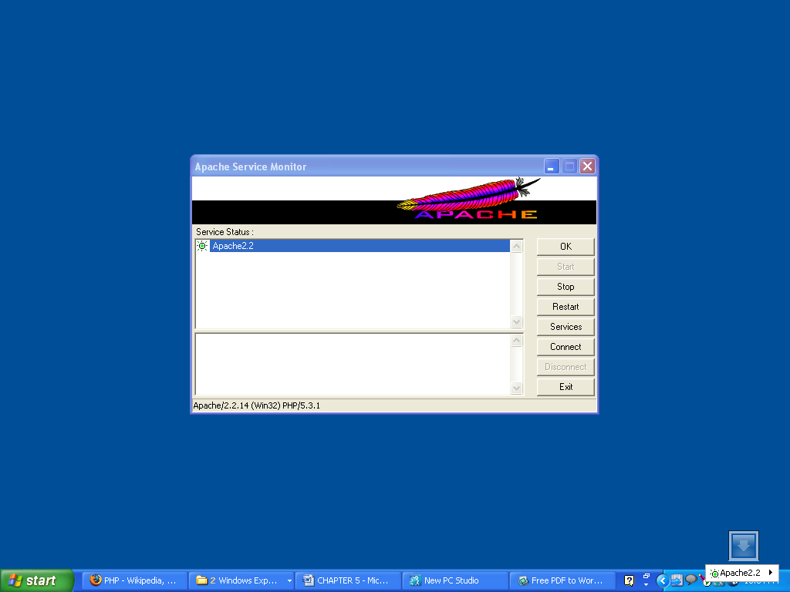

Figure 9.2 APACHE Service Monitor

**CONCLUSION**

Car rental business has emerged with a new goodies compared to the past experience where every activity concerning car rental business is limited to a physical location only. Even though the physical location has not been totally eradicated; the nature of functions and how these functions are achieved has been reshaped by the power of internet. Nowadays, customers can reserve cars online, rent car online, and have the car brought to their door step once the customer is a registered member or go to the office to pick the car.

The web based car rental system has offered an advantage to both customers as well as Car Rental Company to efficiently and effectively manage the business and satisfies customers’ need at the click of a button.

**BIBLIOGRAPHY AND REFERENCES**

**Books Used:**

* Software Engineering - R.S. Pressman
* PHP For Dummies
* PHP Begineers Guide By McGrawhill Publication
* Javascript By McGrawhill Publication

**References Used:**

* <http://www.carrentingsolutions.com/>
* http://www.flashvortex.com/
* <http://www.imscart.com/car_rental_software.html>
* Wikipedia.org
* www.w3schools.com